# Aditya Kumar Week 2 Task

## Task 1: Compression of an Image file using Lambda and S3 using S3 trigger.

Step 1: Created a lambda function and added s3 as trigger and also added a pillow library layer.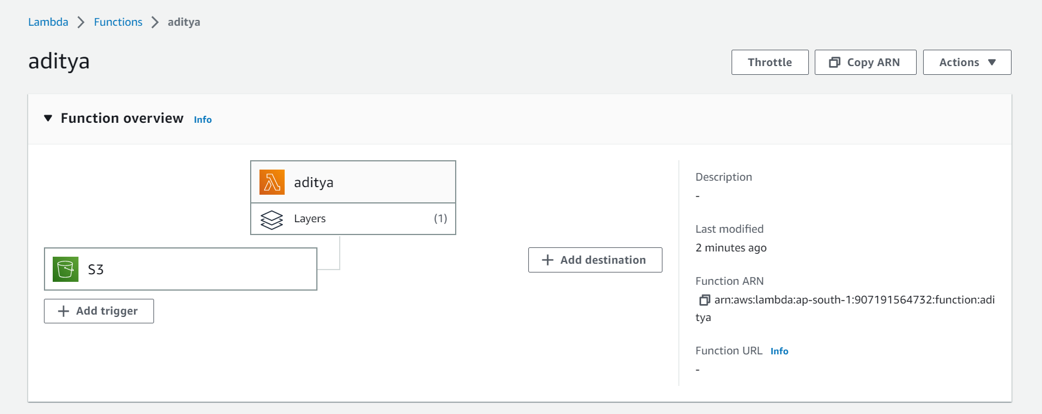

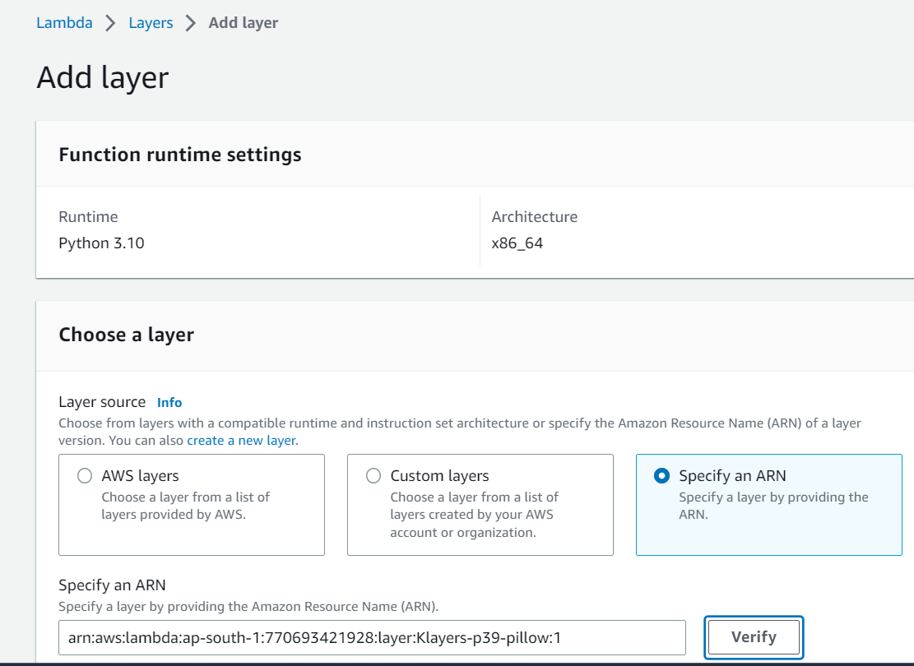

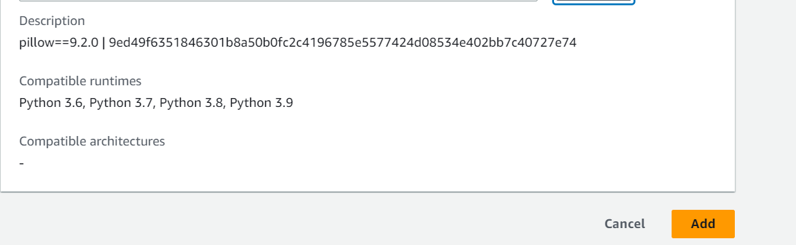

Step 2: Write the python code to compress the image.

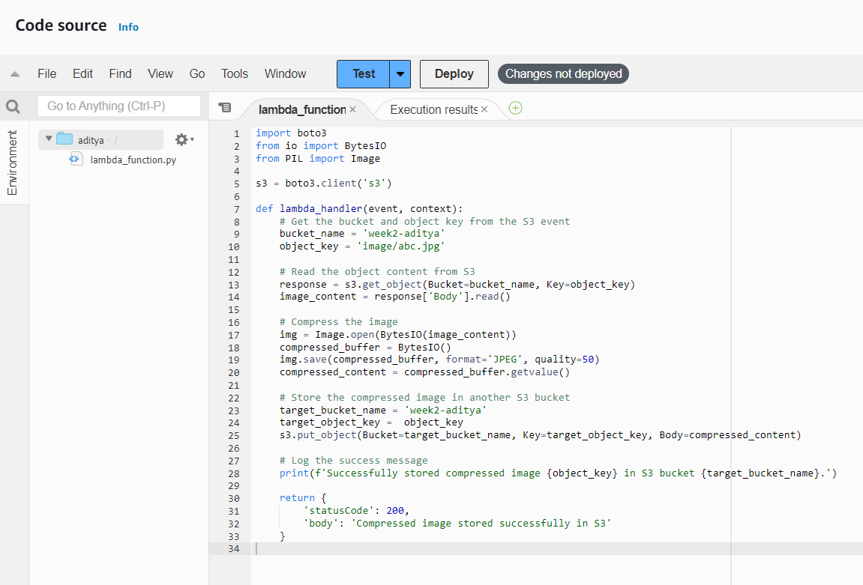

Step 3: Verifying the image size before Testing the code.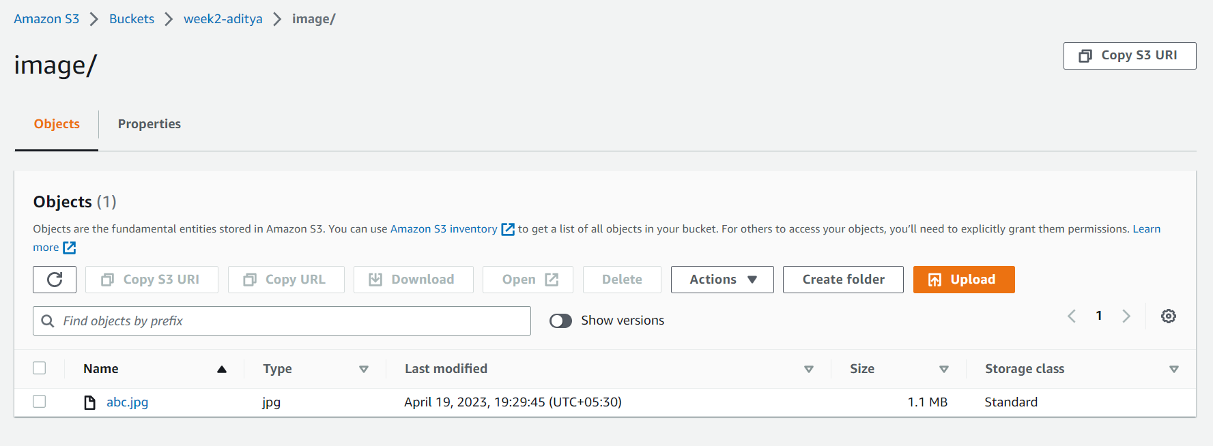

Verifying the size after testing the lambda function . Here we can see that the image size has been compressed.

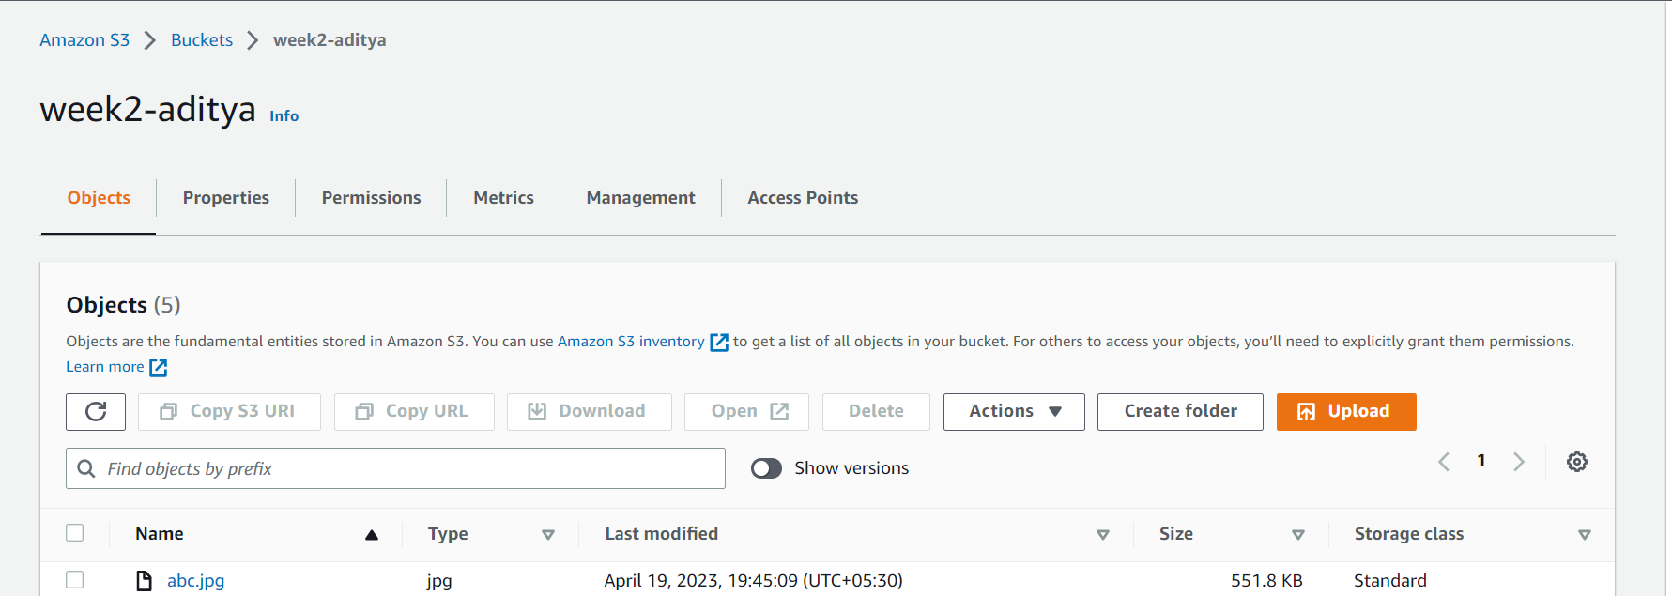

## Task 2 Connect to a database in RDS using Python and query data using mysql-connector and Pandas. Save the queried data as a CSV file in S3. The SQL query might include Filter, GroupBy, and Aggregation clauses. [Each one of the interns will be getting a unique SQL scenario]

Step 1: Created an RDS MySQL server.

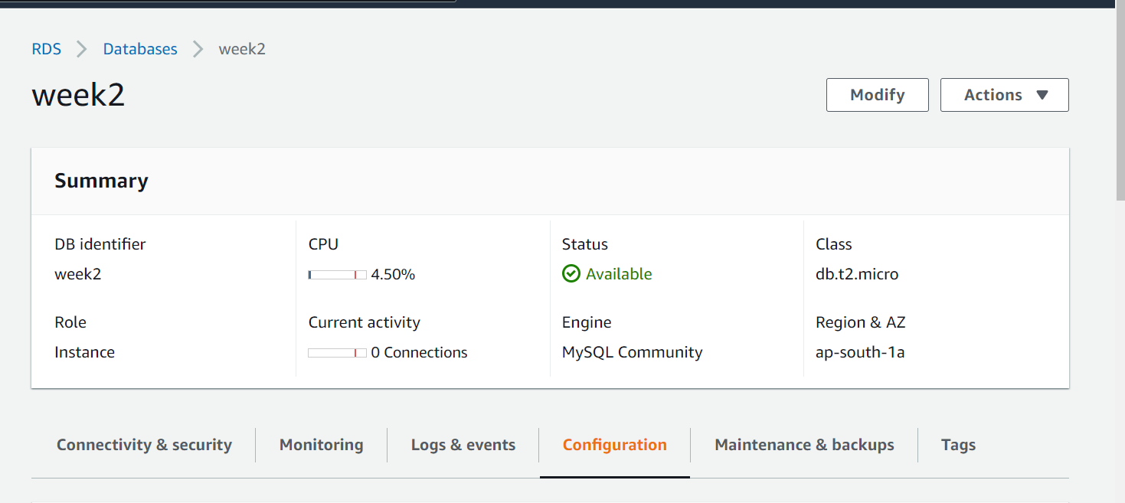

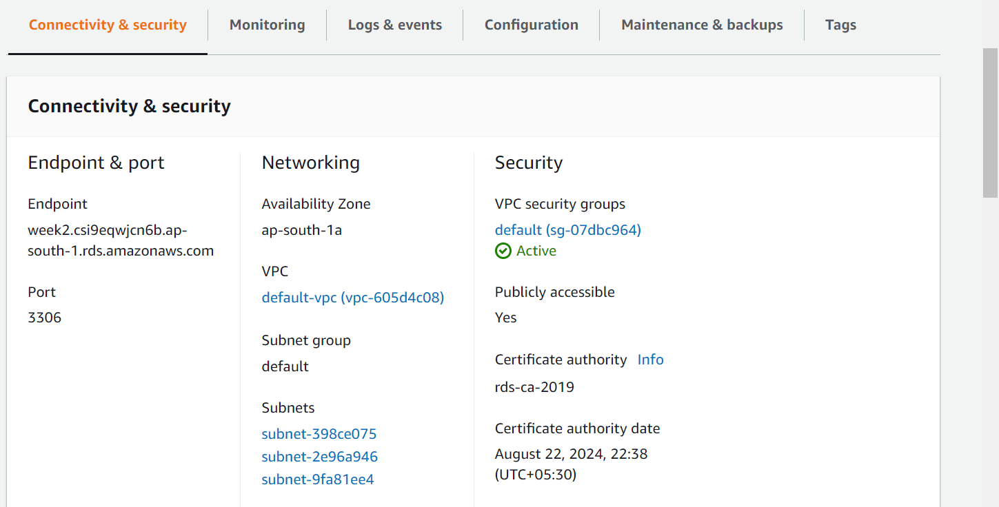

Step 2: Login that MySQL server using DBEVER software and also created a student table and adeed some data.

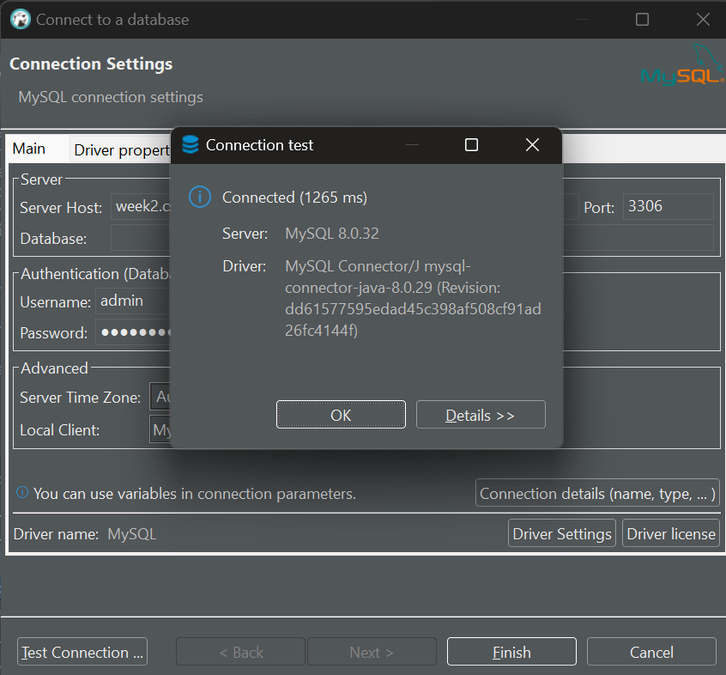

Selecting the database and creating a table to add some into database of MySQL server. Also inserting some values on that table. After that viewing that data.

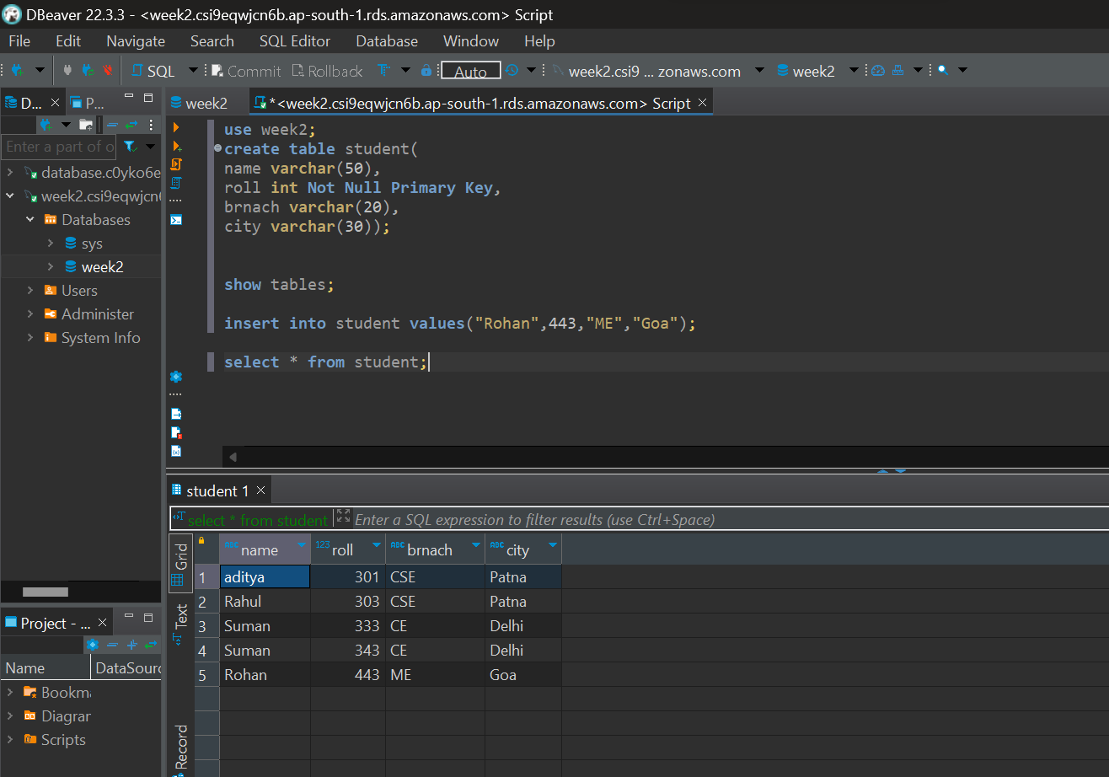

Step 3: Created a EC2 instance to perform query using pandas.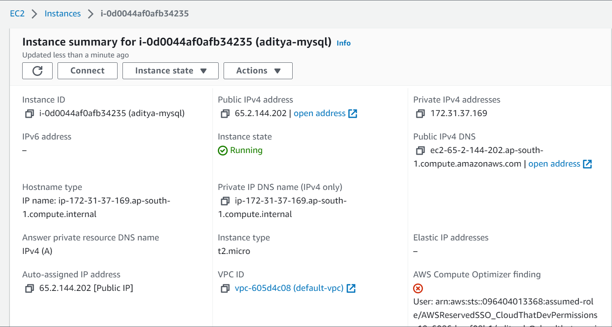Step 4: Login that instance using the SSH connection.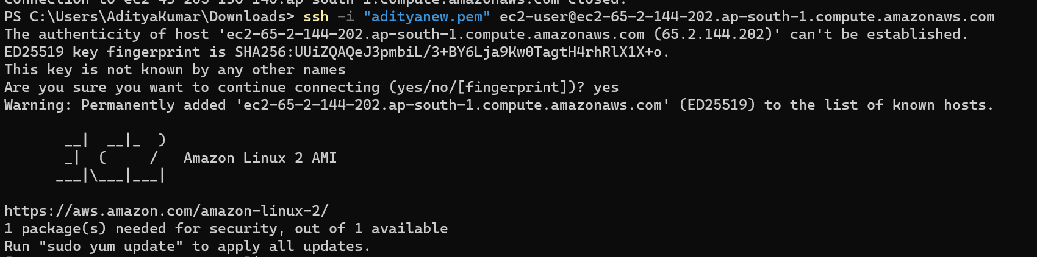

Step 5: Update the ec2 instance and install python3 and pip and required python libraries. Installing Updates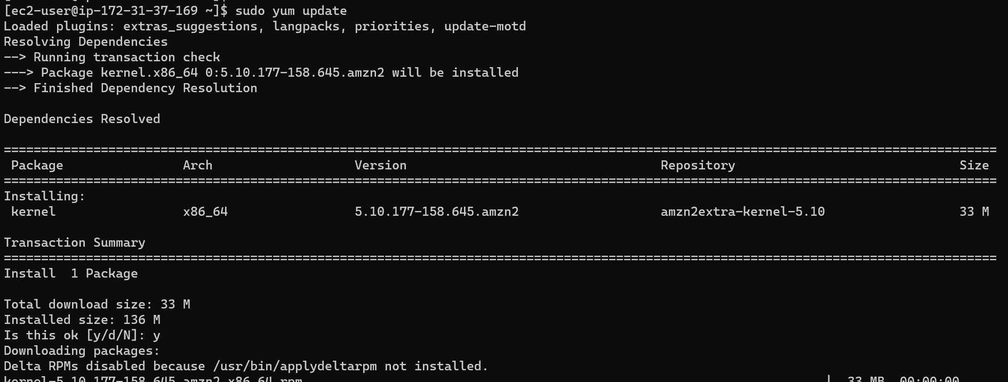Installing Python and checking their version.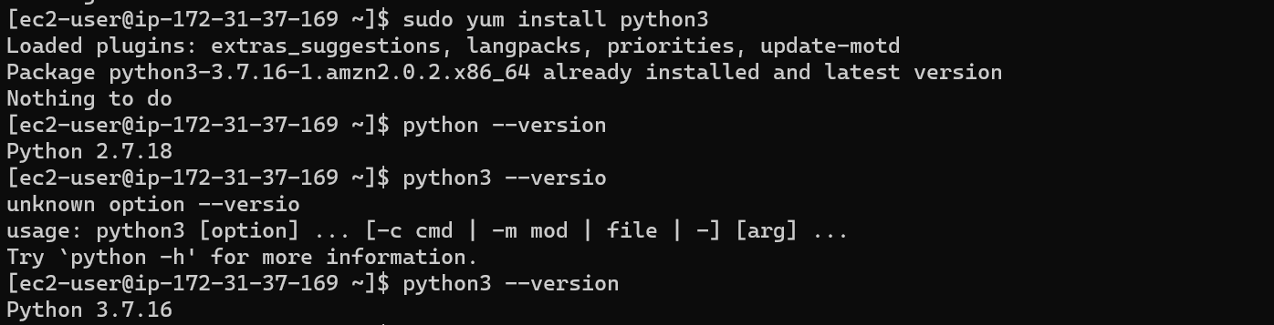

Installing pip and verifying it’s version.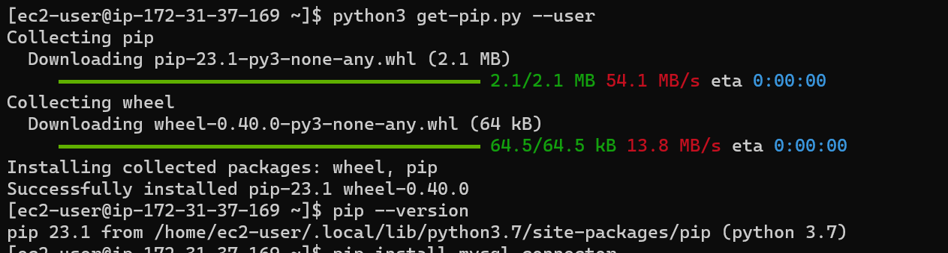Installing MySQL-connecter and Pandas library to perform SQL queries using python.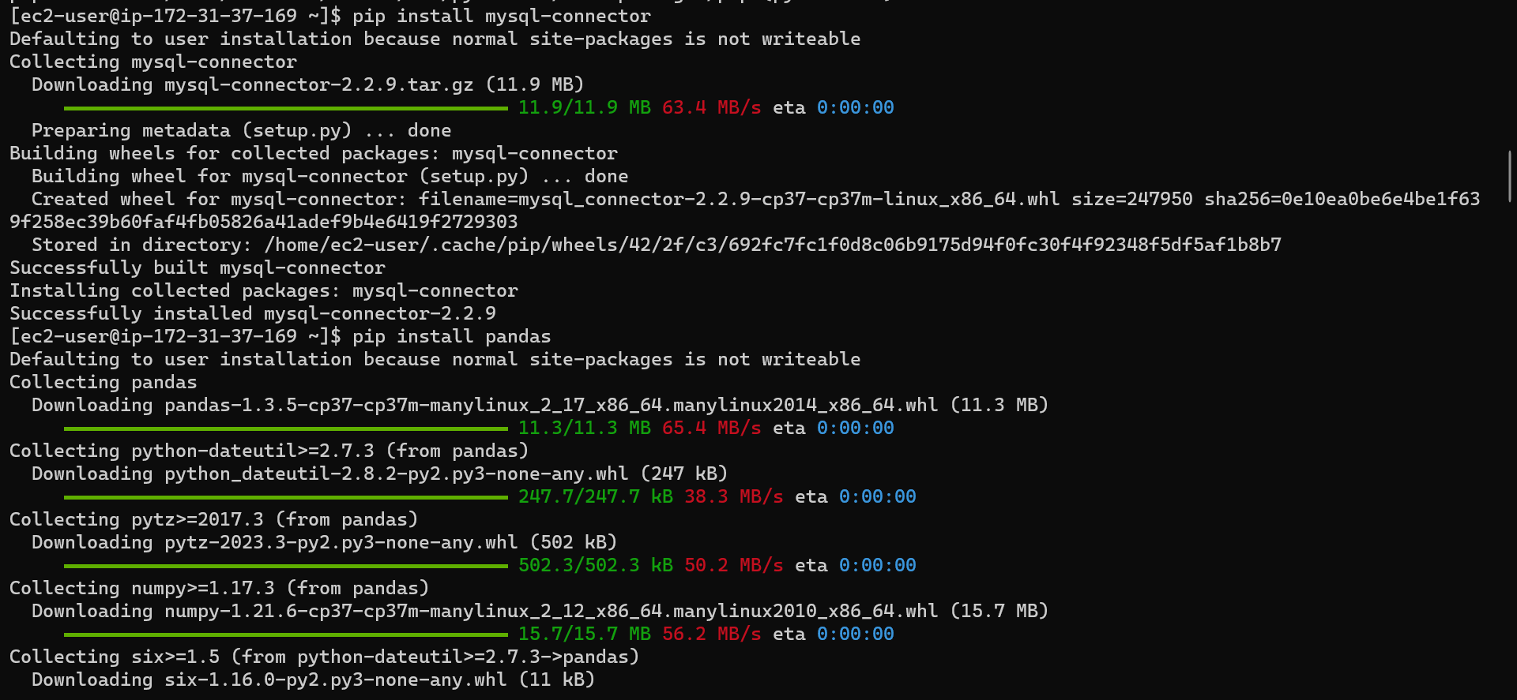Python script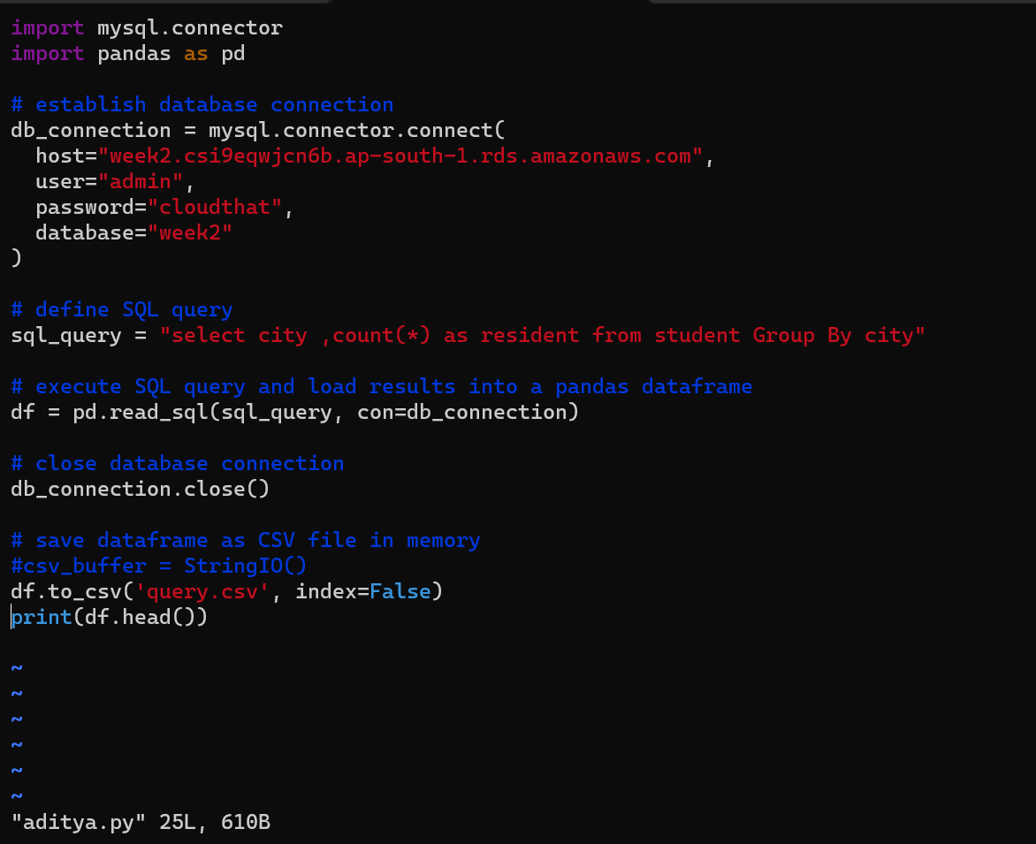

Step 6: Running the python script.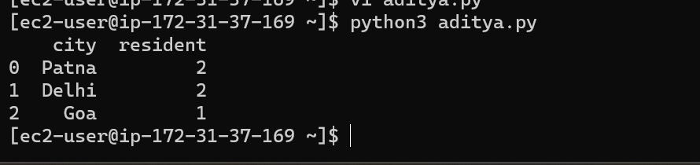after the successful execution of the python script, it saves the query into a csv file. Here we can see that it created by python script.

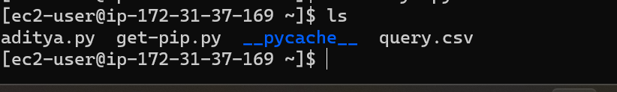

Step 7: Now we have to store the “Query.csv” file on S3 bucket. For that are going to create a S3 bucket.

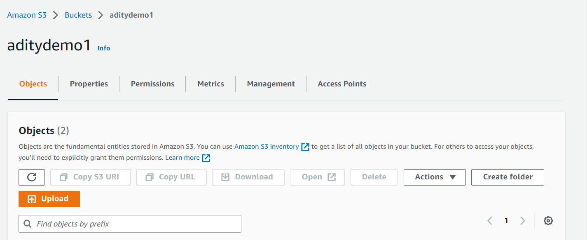

Now we are storing the “Query.csv” file on S3 bucket using the AWS s3 copy command.



Verifying the resources in s3 bucket.

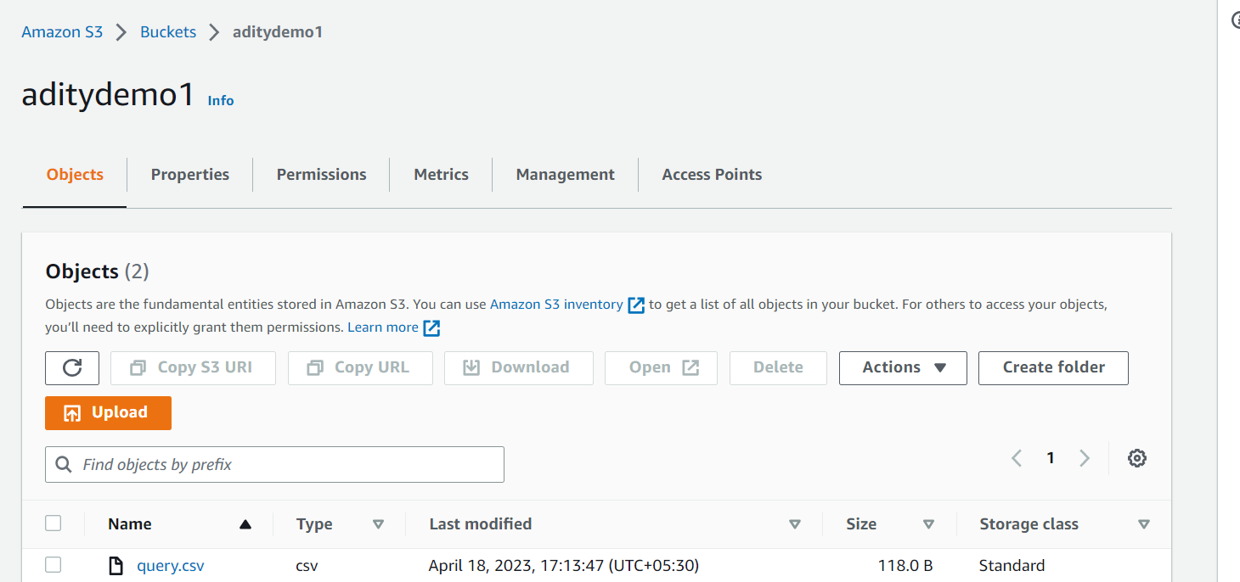

## Task 3: Create an IAM policy to get access to AWS resources.

